west of Butterfield Rd
Town of Halifax, Vermont

Dates: Saturday, October 8th to Thursday, October 13th, 2022

Posted Speed Limit: 35 mph
VOLUME SPEED Total
Daily Average | 332
Week Day Average | 367
Weekend Day Average | 263
Class 2 Passenger Cars — 2 axles, can have 1 or 2 axle trailers | 69.0%
Class 3 Pickups, Vans — 2 axles, 4 tire single units. Can have 1 or 2 axle trailers | 20.5%
Class 5 Single Unit Axle Trucks — 2 axles, 6 tires (dual rear tires), single unit | 6.9%
Other Classes — Including motorcycles, busses, and vehicles with 3 or more axles | 3.6%
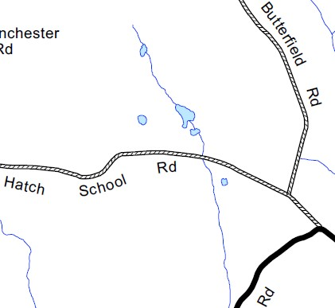
Number of Vehicles per Day
VEHICLES BY CLASS

Average Speed

mph
35
85
th Percentile

42
mph

Percent of Vehicles
>
40 mph

20.5
%

Facing east on Hatch School Rd

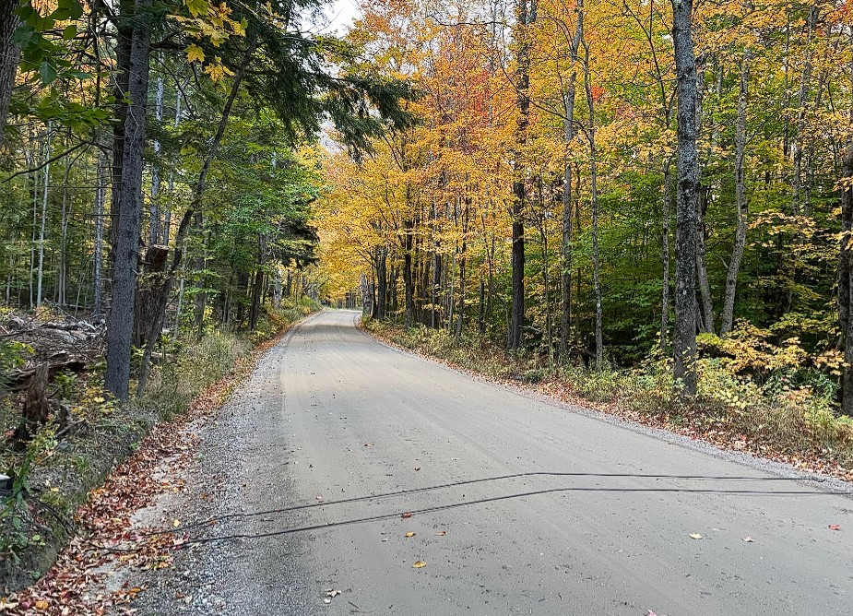
Hatch School Road

Windham Regional
Commission

TRAFFIC COUNT SUMMARY

139 Main Street, Suite 505 / Brattleboro, VT 05301 / Phone: (802) 257-4547 / www.windhamregional.org

