Daily Average | 149
Week Day Average | 159
Weekend Day Average | 135
Average Speed | 34 mph | 32 mph | 35 mph
85th Percentile | 40 mph | 38 mph | 42 mph
Percent of Vehicles > 40 mph | 16.7% | 11.8% | 19.9%
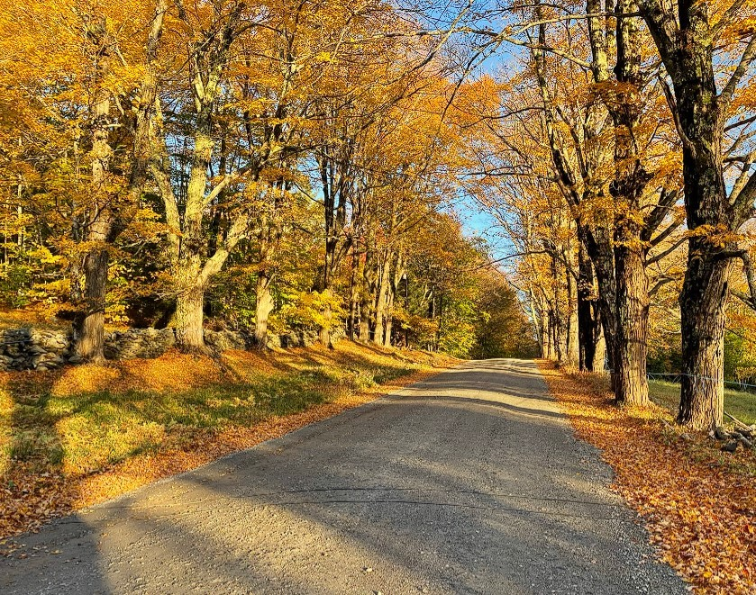
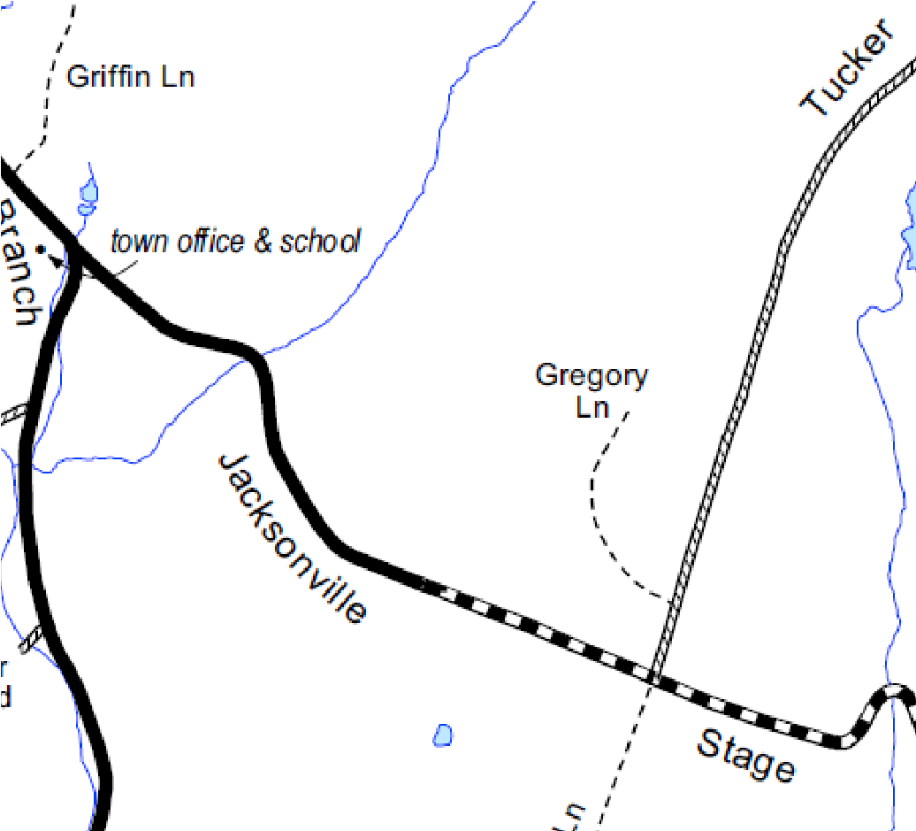
SPEED Total Eastbound Westbound
Jacksonville Stage Road

west of Tucker Rd

Town of Halifax, Vermont

Dates:
Saturday, October 15th to Wednesday, October 19th, 2022

Posted Speed Limit:
none posted
—
35
per ordinance

VOLUME

Number of Vehicles per Day

Windham Regional
Commission

TRAFFIC COUNT SUMMARY

Facing east on Jacksonville Stage Road

*Vehicle class data at this location not included due to an unusually high number of unclassed vehicles, possibly due to road conditions at the time of the count
139 Main Street, Suite 505 / Brattleboro, VT 05301 / Phone: (802) 257-4547 / www.windhamregional.org

