Moss Hollow Road
north of Green River Rd
Town of Halifax, Vermont

Dates: Saturday, October 15th to Wednesday, October 19th, 2022

Posted Speed Limit: 35 mph
VOLUME
Number of Vehicles per Day
Windham Regional
Commission

TRAFFIC COUNT SUMMARY

Daily Average | 129
Week Day Average | 125
Weekend Day Average | 137
SPEED
Average Speed | 30 mph
85th Percentile | 34 mph
Percent of Vehicles > 35 mph | 12.5%
*Vehicle class data at this location not included due to an unusually high number of unclassed vehicles, possibly due to road conditions at the time of the count

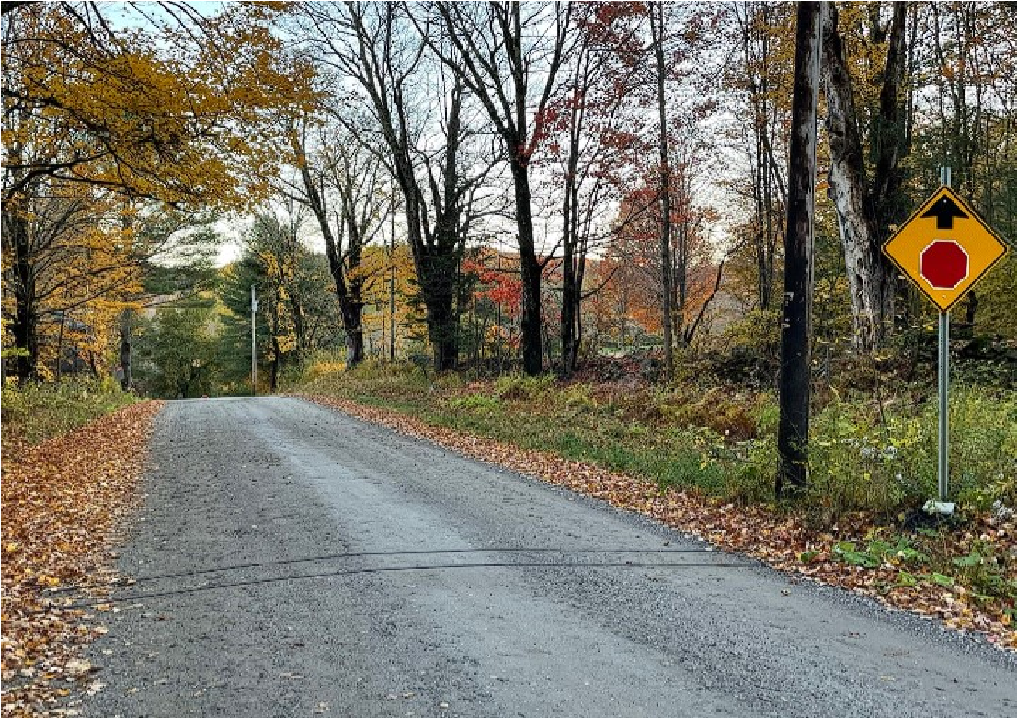
Facing south on Moss Hollow Road
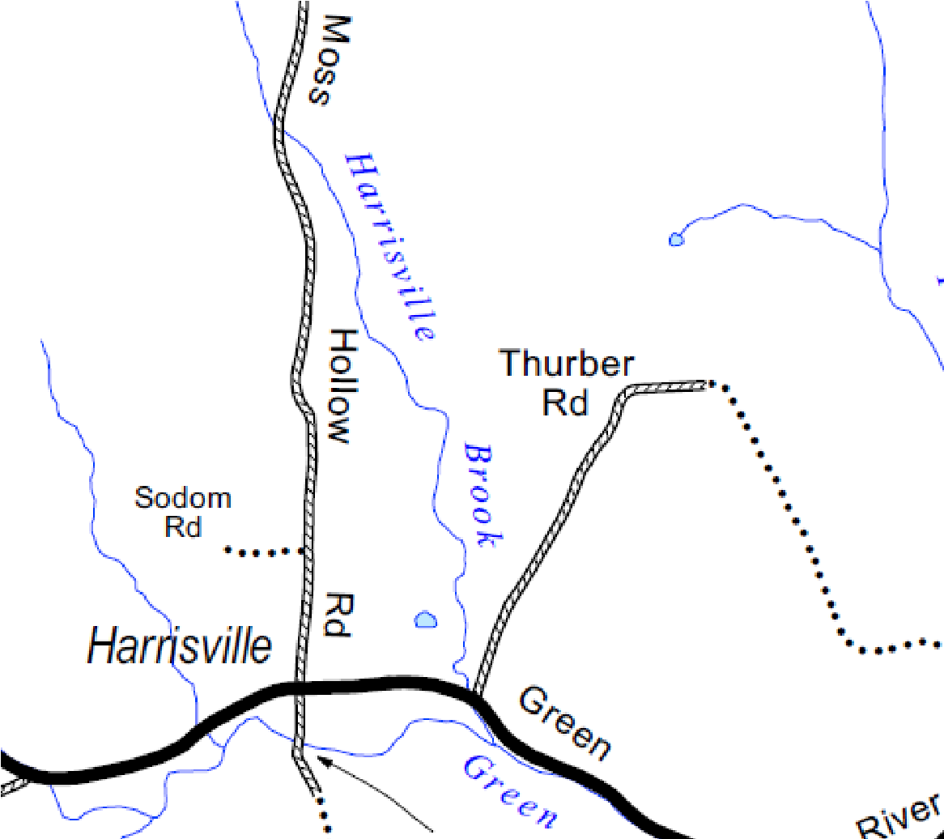

139 Main Street, Suite 505 / Brattleboro, VT 05301 / Phone: (802) 257-4547 / www.windhamregional.org

