|  |  |  |  |  |  |  |  |  |  |  |  |  |  |  |  |  |  |  |  |
| --- | --- | --- | --- | --- | --- | --- | --- | --- | --- | --- | --- | --- | --- | --- | --- | --- | --- | --- | --- |
| |  |  | | --- | --- | | Daily Average | 318 | | Week Day Average | 349 | | Weekend Day Average | 256 | | |  |  |  |  | | --- | --- | --- | --- | | Average Speed | 34 mph | 36 mph | 33 mph | | 85th Percentile | 40 mph | 42 mph | 39 mph | | Percent of Vehicles > 40 mph | 16.6% | 17.2% | 10.6% | |

|  |  |  |  |  |  |  |  |  |  |
| --- | --- | --- | --- | --- | --- | --- | --- | --- | --- |
| |  |  | | --- | --- | | Class 2 Passenger Cars — 2 axles, can have 1 or 2 axle trailers | 62.6% | | Class 3 Pickups, Vans — 2 axles, 4 tire single units. Can have 1 or 2 axle trailers | 21.9% | | Class 5 Single Unit Axle Trucks — 2 axles, 6 tires (dual rear tires), single unit | 11.9% | | Other Classes — Including motorcycles, busses, and vehicles with 3 or more axles | 3.6% | |  |

VEHICLES BY CLASS

Hatch School Road

west of Shearer Hill Rd

VOLUME

*Number of Vehicles per Day*

Town of Halifax, Vermont

Dates:

Saturday, October 8th to Thursday, October 13th, 2022

Posted Speed Limit:

mph

35

Windham Regional

Commission

TRAFFIC COUNT SUMMARY

SPEED

*Total Eastbound Westbound*

*Facing east on Hatch School Rd*

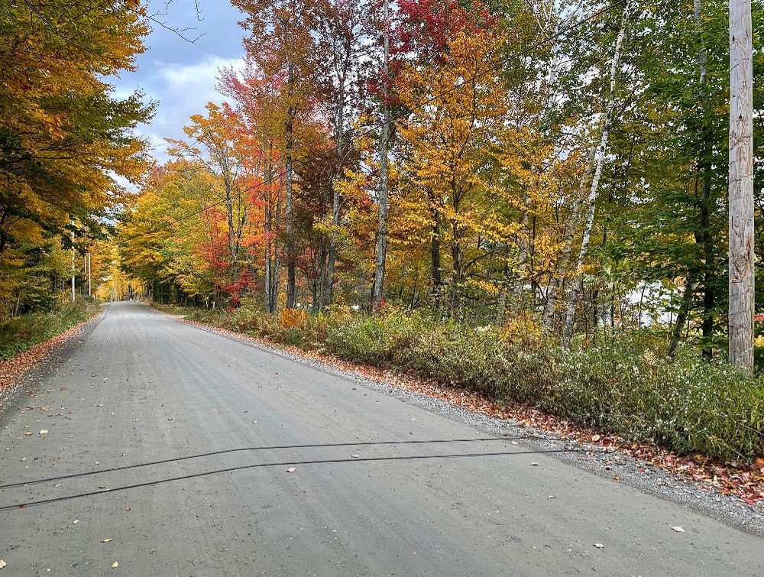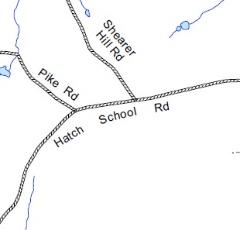

139 Main Street, Suite 505 / Brattleboro, VT 05301 / Phone: (802) 257-4547 / www.windhamregional.org